K-Fold Cross Validation

K-Fold Cross Validation is a statistical technique to measure the performance of a machine learning model by dividing the dataset into K subsets of equal size (folds)
The performance of the model is then averaged over all K iterations to provide a robust estimate of its generalization ability.

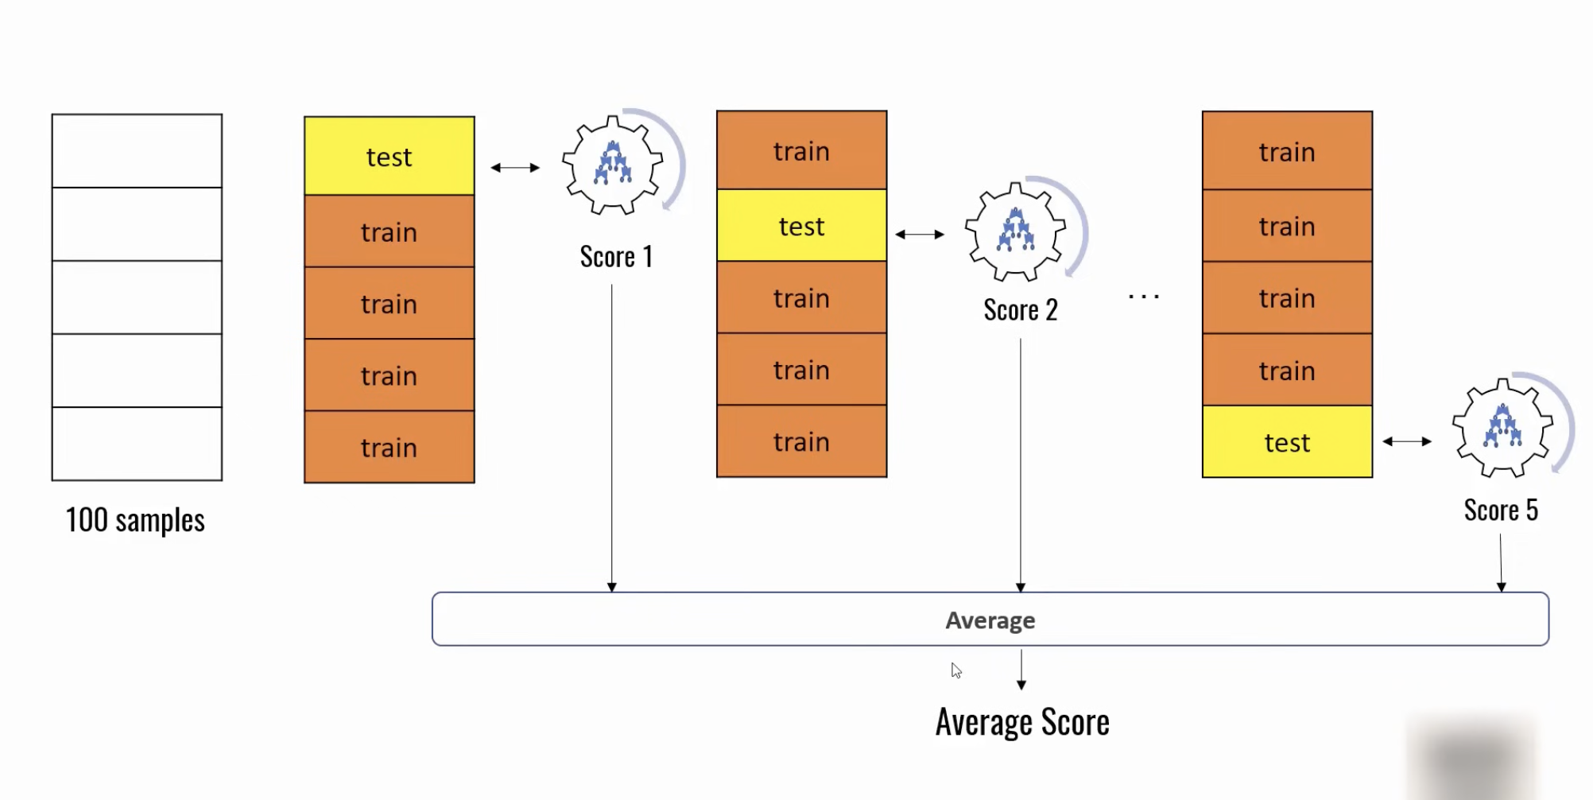

Steps:

1. Split Data into K Folds:

2. Choosing the Value of K
The choice of K affects the trade-off between bias and variance:
- Small K (e.g., K =2 or K=5): Faster computation with increased variance in performance estimates.
- Large K (e.g., K =10 or K =n, where n is the size of the dataset): Lower variance but higher computational cost.
A standard choice is 10-Fold Cross Validation that is a good trade-off between bias and variance in most situations.

Benefits of K-Fold Cross Validation
- Efficient Data Usage: Every data point is used for both training and testing.
- Reliable Estimates: Reduces the likelihood of overfitting or underfitting.
- Applicability: Works well with small datasets or when data collection is expensive.

Limitations of K-Fold Cross Validation
- Computational Cost: Re-training the model k times can be time-consuming, especially for large datasets or complex models.
- Data Leakage Risk: Care must be taken to ensure that no data preprocessing (e.g., scaling, encoding) leaks information from the test set into the training set.
- Not Ideal for Time-Series Data:

Stratified K Fold Cross Validation

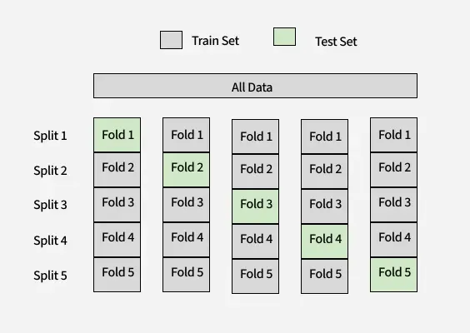

- 80 samples are Class 0
- 20 samples are Class 1
Using stratified sampling on same dataset:
1. Training Set (80 samples):
- 64 from Class 0 (80% of 80)
- 16 from Class 1 (80% of 20)
2. Test Set (20 samples):
- 16 from Class 0 (20% of 80)
- 4 from Class 1 (20% of 20)
Advantages:
- Handles Imbalance data properly.
- Prevents Misleading Metrics
Disadvantages:
- Useless for time-series data
- If data is small it can overfit.

Time-Aware Validation
Instead of random splits, it respects time order and evaluates models in a way that mimics real-world deployment.
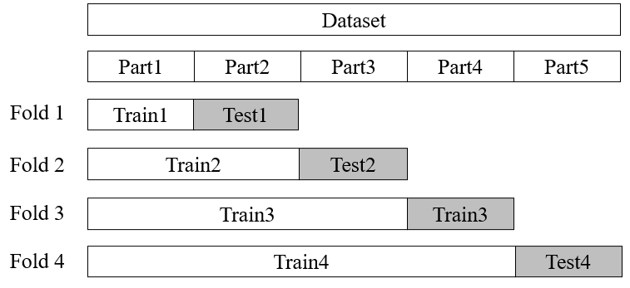
Three key insights:

1. Time sensitivity (concept drift)
- Data changes over time.
- Same model + same size data → different performance at different time periods.

2. Model decay
- Models degrade as time passes.
- Patterns learned earlier become outdated.

3. Training size impact
Two ways to test this:
(a) Expanding window
- Train on more and more past data, test on next time chunk.
- Example: Train(1) → Test(2), Train(1+2) → Test(3)
- Good for seeing if more data helps.
(b) Fixed test set
- Keep the same future test set.
- Increase training data gradually.

Method 1: Train → Past, Test → Future
Example:
- Train: Jan → June
- Test: July → Aug

Method 2: Rolling Window
Train and expand over time:
- Fold 1: Train (Jan–Mar) → Test (Apr)
- Fold 2: Train (Jan–Apr) → Test (May)
- Fold 3: Train (Jan–May) → Test (June)

